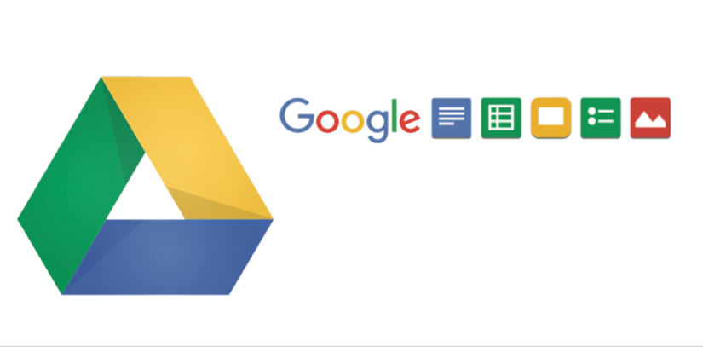

Contact Us To Learn More!

Google Drive for Work makes it easy to access your files from any smartphone, tablet, or computer.

Share them instantly with teammates, customers or partners - even with people that don’t use Google Drive.

Drive for Work

All your work, safe, available everywhere and easy to share.

Unlimited storage, including file sup to 5 TB

Enhanced audit view – admins see activity like moving, sharing and deleting files within or outside the company.

Intuitive admin console.

Includes Google Apps Vault – expanded to cover all of the content in Drive, including Docs, Sheets and Slides.

All files uploaded to Google Drive are encrypted from your device to Google, in transit and at rest in Google’s servers.

New security controls – admins can set sync client, offline Drive app and add-on settings at the Organizational Unit (OU) level.

99.9% uptime guarantee!

BENEFITS

FEATURES

Work without limits.

Comprehensive new security controls, paired with the **Google Apps for Work** **suite of solutions** allows for **fluid, unparalleled team collaboration.**

Google Drive for Work is a premium cloud offering for organizations

that includes **unlimited data storage**, and accessibility to all files, folders

and backups from anywhere, on any device.

GOOGLEDRIVEFORWORK

ALL YOUR WORK: IMMEDIATELY ACCESSIBLE, SAFE AND EASY TO SHARE.

Increased productivity and collaboration through accessibility from anywhere – Mobile (iOS and Android support).

Improved sharing with non-Google Apps or Drive users.

No limits on file editing – even with Microsoft Office files.

Fine-grained control and increased visibility to team activity.

More organizational security at every layer (mobile security, eDiscovery, suspicious login detection).

Heightened collaboration with Google Apps for Work solutions, like Drive, Docs and Hangouts!

CONTACTUS



Stephen.silver@comprehensive-tel.com

866-225-8750

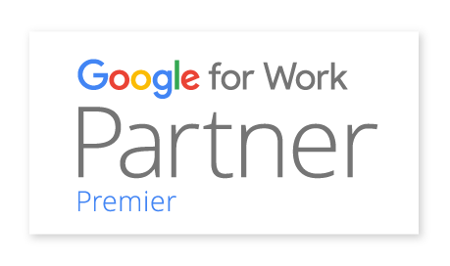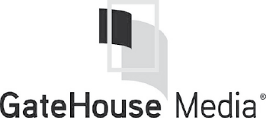

Stephen.silver@comprehensive-tel.com

866-225-8750

The planning, preparation and training (SADA) led us through made this a relatively painless move. SADA has been very responsive on any support issues and follow up projects post rollout.

Founded in 2000, SADA Systems, Inc. is a privately-held global leader in providing cloud computing and strategic IT solutions to organizations worldwide. As a Google for Work Premier Partner, SADA Systems has proven expertise in enterprise consulting, cloud platform migration, custom application development, managed services, user adoption and change management.

Named Global Partner of the Year for Google Maps for 2014   
and 2015, as well as 2013 North America Partner of the Year for Government, SADA has a successful track record of delivering all Google for Work cloud solutions, including Google Apps, Google Drive for Work, Google Cloud Platform, Chrome, Google Search for Work, and Google Maps for Work.

AFEWOFOURCLIENTS

**HOWARD KOLODNY**

VP of IT,

AT Z Gallerie

ABOUTSADASYSTEMS

CONTACTUS