

Stephen.silver@comprehensive-tel.com

As a Google for Work Premier Partner, SADA Systems specializes in the deployment, implementation

and training around Google for Work enterprise solutions.

**Cloud Solutions For   
Your Business**

Familiar tools that will help you work the way you live, customized and optimized for your enterprise by SADA Systems

GOOGLEFORWORKENTERPRISESOLUTIONS

**GOOGLE FOR WORK ENTERPRISE CLOUD SOLUTIONS WITH SADA SYSTEMS**

Leveraging over a decade of experience with Google cloud-based apps and solutions, SADA Systems’ team of certified experts provide organizations with customized Google cloud solutions, productivity apps and user-adoption training to increase organizational efficiency and collaboration anytime, anywhere, and on any device.

CONTACTUS

BENEFITS

SADA SERVICES

SOLUTIONS

**Drive for Work -** securely share and sync documents, all with unlimited storage

**Apps for Work -** cloud storage,

emailing, calendaring and more

**Search for Work -** find what you

need fast with internal and external search solutions specific to your business

**Maps for Work -** customizable,

robust mapping solutions and tools tailor-made for your organization’s needs

**Cloud Platform -** cloud-based

services that allow your organization the freedom and flexibility to build, test and deploy applications

**Consultancy -** delivering assessment   
and discovery with customized solutions and recommendations by our team of Google certified experts

**Migration -** providing seamless transition

from your legacy environment to cloud

**Deployment -** expert provisioning and

configuration of your IT environment

**Managed Services -** efficient management   
of your cloud environment with SADA CloudServ

**App Development -** custom app

development for your business needs

**User Adoption and Training -** providing

strategic framework to drive user-adoption

and consumption

Onsite assessment to strategize a tailor-made

solution and accelerate delivery timelines

Efficient project management to streamline

processes and eliminate delays

Address business challenges with strategies

to transform your organization

Familiar, cost-effective, enterprise-grade

solutions providing reliability and security

User Adoption Consulting to drive

transformation and enhance overall migration experience

24/7/365 access to certified Google

technicians

Leverage SADA’s Premier Partner

status with Google to quickly resolve issues

866-225-8750

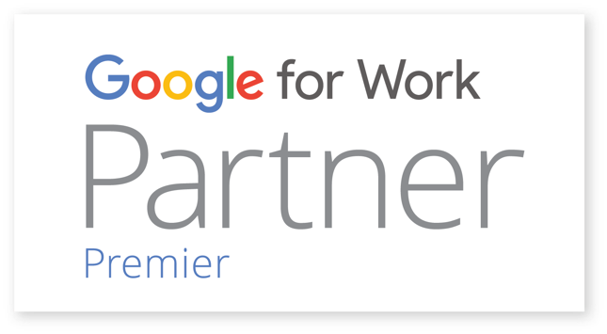

Stephen.silver@comprehensive-tel.com

I have complete confidence in everything SADA System does; the migration was fantastic and everyone I worked with was fantastic.

DAVID HOLM,

Director of IT,

Aerotech

Founded in 2000, SADA Systems, Inc. is a privately-held global leader in providing cloud computing and strategic IT solutions to organizations worldwide. As a Google for Work Premier Partner, SADA Systems has proven expertise in enterprise consulting, cloud platform migration, custom application development, managed services, user adoption and change management.

Named Global Partner of the Year for Google Maps for 2014 and 2015, as well as 2013 North America Partner of the Year for Government, SADA has a successful track record of delivering all Google for Work cloud solutions, including Google Apps, Google Drive for Work, Google Cloud Platform, Chrome, Google Search for Work, and Google Maps for Work.

AFEWOFOURCLIENTS

ABOUTSADASYSTEMS

CONTACTUS

866-225-8750